Exercise 22: Demo about Optional parameters and Link

Objectives and Outcomes
This exercise is a demo that showcases how to use optional parameters and the Link component in React using react-router-dom version 6. In this example, we'll create a simple navigation menu with links that can accept optional parameters.

Exercises
- Create Navbar as image below

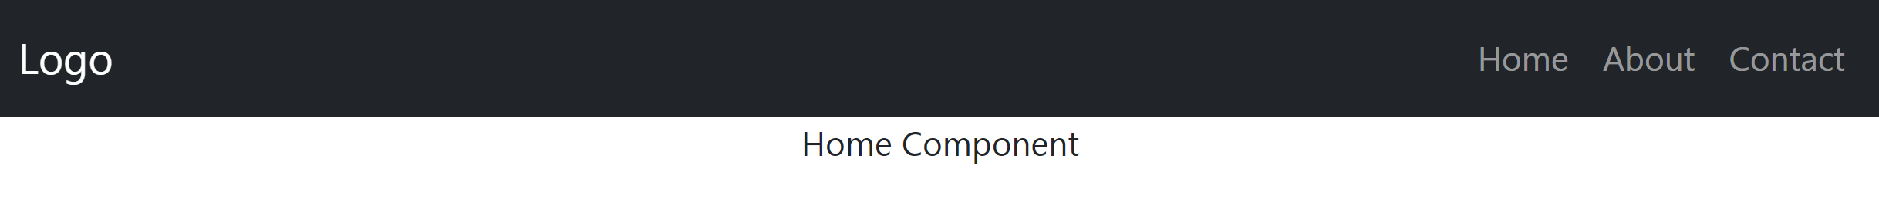
Install:
"react-router-dom": "^6.16.0"
"reactstrap": "^9.2.0"

const Home = () => <div align='center'>Home Component</div>;
const About = () => <div align='center'>About Component</div>;
const Contact = () => <div align='center'>Contact Component</div>;
const Profile = () => <div align='center'>Profile Component</div>;

const CustomNavbar = () => {
return (
<Navbar color="dark" dark expand="md">
<NavbarBrand tag={Link} to="/">Logo</NavbarBrand>
<Nav className="mr-auto" navbar>
<NavItem>
<NavLink tag={Link} to="/" exact>Home</NavLink>
</NavItem>
<NavItem>
<NavLink tag={Link} to="/about">About</NavLink>
</NavItem>
<NavItem>
<NavLink tag={Link} to="/contact">Contact</NavLink>
</NavItem>
</Nav>
</Navbar>
);
};

const App = () => {
return (
<Router>
<CustomNavbar />
<Routes>
<Route path="/" exact element={<Home />} />
<Route path="/about" element={<About />} />
<Route path="/contact" element={<Contact />} />
<Route path="/profile" element={<Profile />} />
</Routes>
</Router>
);
};

Conclusion
This demo demonstrates how to use optional parameters and the Link component in React using react-router-dom version 6.

